Harrington Opera House and Bank Block
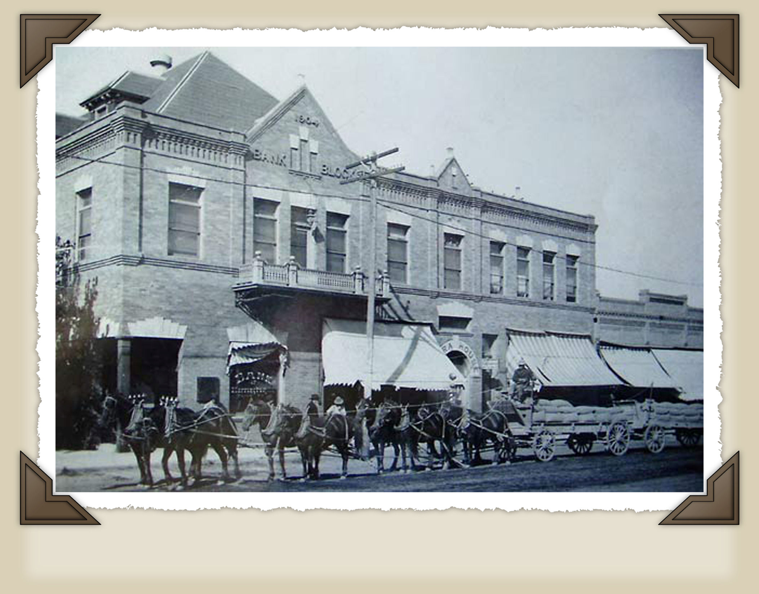

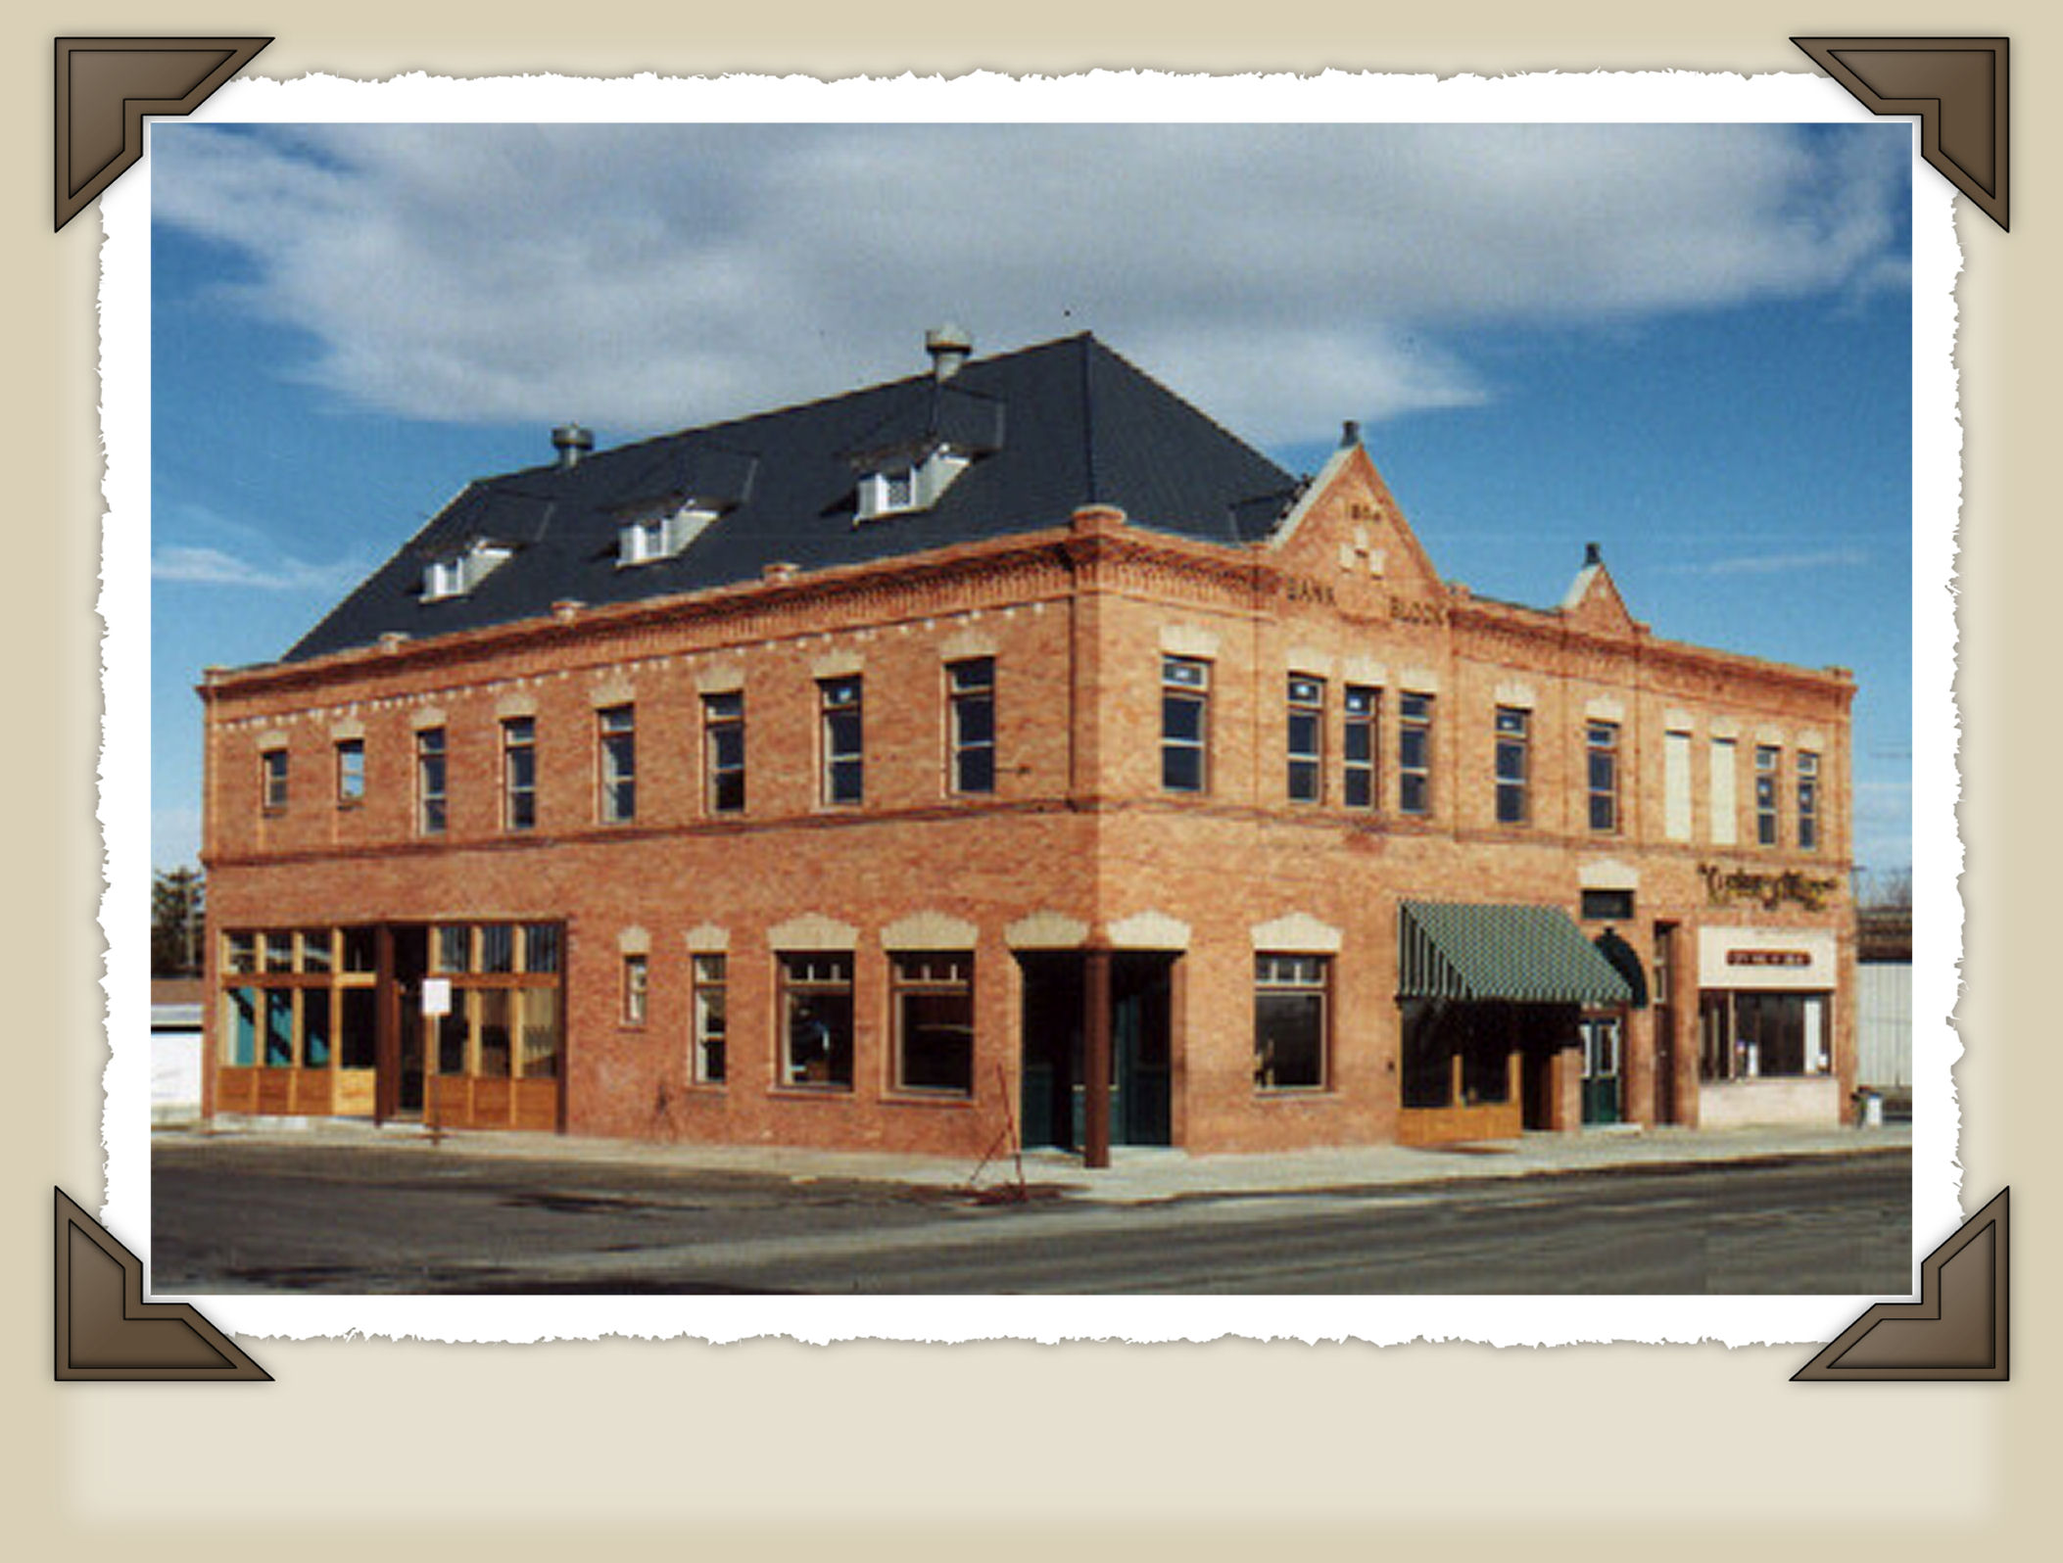
Photo from early 1900’s
Photo from 2000

